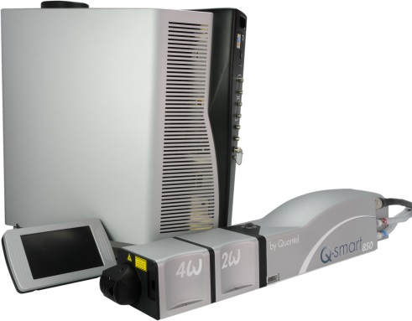**QSMART – PUMP CHAMBER REPLACEMENT**

**PROCEDURE**

**Toolkit:**

Allen keys set - metric

Cover interlock holder RM100016A

Software loading harness SM020006A

Optical table

**System**: QSMART

|  |  |  |  |  |  |  |  |  |  |  |
| --- | --- | --- | --- | --- | --- | --- | --- | --- | --- | --- |
| |  |  | | --- | --- | | SM010340  SM010341 | **PUMP CHAMBER W OPT**  **PUMP CHAMBER W OPT S/E** | | | | | |  |  |  |  |
|  | | | | |  |  |  |  |
|  |  |  |  |
|  |

**Purpose**: This procedure describes the integration of the complete pump chamber of a QSmart

|  |  |  |
| --- | --- | --- |
| Revision | date | modification |
| Initial issue | July 4, 2014 |  |
|  |  |  |
|  |  |  |
|  |  |  |

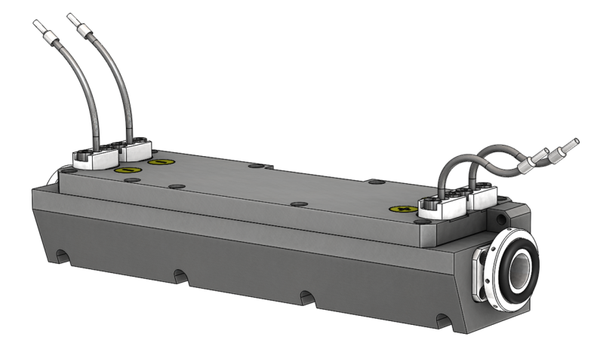

# DISASSEMBLING

* Turn the system off
* Disconnect cables and water hoses on the laser head side
* Remove the laser head cover.
* Remove the side plate (7 BHC 3x6)

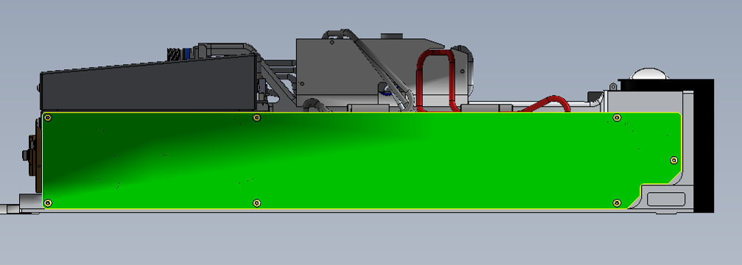

* Remove the trigger cable (keep the CHC 3x6 screw + ZU3 washer).

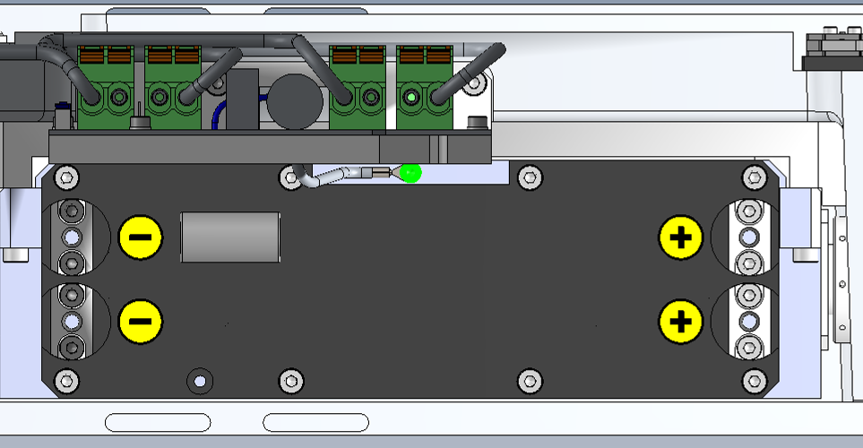

* Disconnect flash lamp wires from Trigger Board

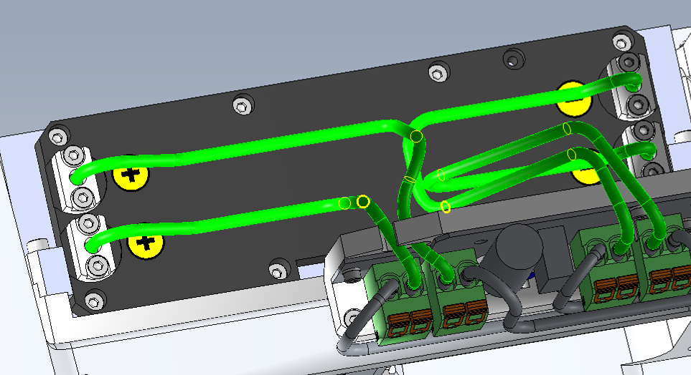

* Unscrew the 2 O-rings located on both sides of the pump chamber
* Remove the screw which maintain the cable coming from the TRI board on the pump chamber.
* Remove the pump chamber by unscrew the 4 screws

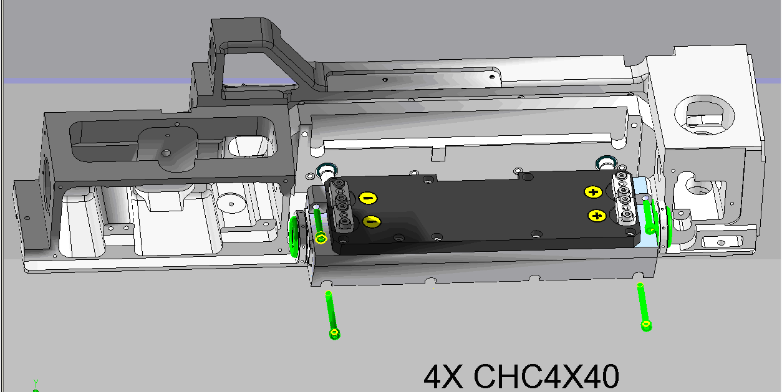

# IMPLEMENTATION OF THE NEW PUMPING CHAMBER

* Fasten the laser head on the optical table (3 points)
* Put the new sealing rings (3/E/0666) on each side then slide the pumping chamber on water pipes. First screw the 2 upper CHC 4x25 screws, then the lower CHC 4x40 ones
* Adjust nuts to push sealing rings on the main structure.
* Connect flash lamp wires on the trigger board
* 
* Fasten the trigger cable (CHC 3x6 screw + ZU3 washer).



* Connect the power supply cable to the laser head
* Fill the cooling group water tank, verify water level (see User Manual)
* Connect water hoses. Check for color codes.
* Defeat cover interlock with tool RM100016A
* Turn on the power supply cabinet.
* Check that the Shutter Led lights up at turn on then shuts off
* Adjust tank water level

# LASER ADJUSTMENT (Beam analyzer or burn paper)

*Refer to Laser Adjustment procedure.*

* Close the Laser head and put warranty stickers   
  *Refer to "LH-Warranty Labels"*